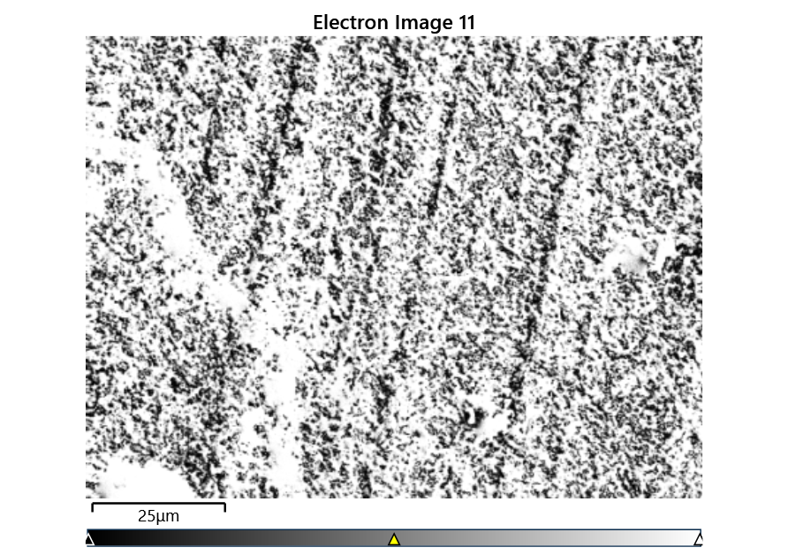



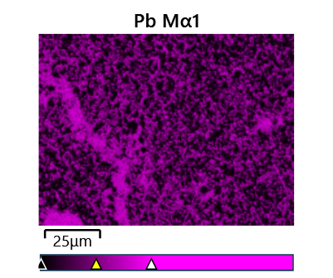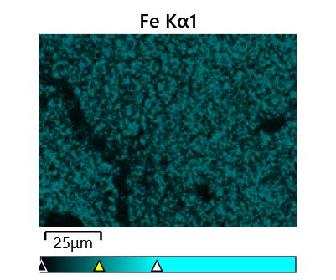

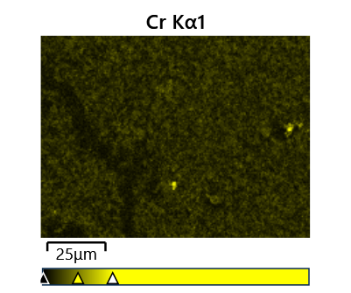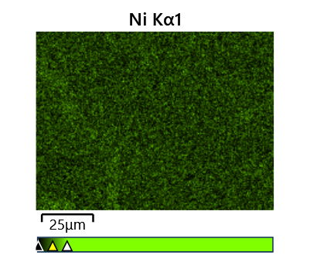

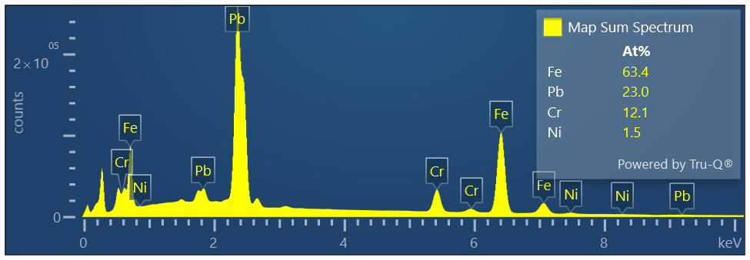

Map Sum Spectrum

Element Signal Weight % σ

Pb 52.81 0.05

Fe 39.25 0.05

Cr 6.98 0.02

Ni 0.96 0.03

Map Sum Spectrum

Element Signal Atomic % σ

Fe 63.41

Pb 23.00

Cr 12.11

Ni 1.47